SCHOOL

Trial WACE Examination, 2012

Question/Answer Booklet

MATHEMATICS 2A/2B
SOLUTIONS

Section Two:

Calculator-assumed

Student Number: In figures

In words

Your name

Time allowed for this section
Reading time before commencing work: ten minutes
Working time for this section: one hundred minutes

Materials required/recommended for this section

To be provided by the supervisor
This Question/Answer Booklet
Formula Sheet (retained from Section One)

To be provided by the candidate
Standard items: pens, pencils, pencil sharpener, eraser, correction fluid/tape, ruler, highlighters

Special items: drawing instruments, templates, notes on two unfolded sheets of A4 paper, and up to three calculators satisfying the conditions set by the Curriculum Council for this examination.

Important note to candidates

No other items may be used in this section of the examination. It is your responsibility to ensure that you do not have any unauthorised notes or other items of a non-personal nature in the examination room. If you have any unauthorised material with you, hand it to the supervisor before reading any further.

Structure of this paper

Section | Number of questions available | Number of questions to be answered | Working time (minutes) | Marks available | Percentage of exam
Section One:  Calculator-free | 7 | 7 | 50 | 50 | 33
Section Two:  Calculator-assumed | 13 | 13 | 100 | 100 | 67
 |  |  | Total | 150 | 100

Instructions to candidates

- The rules for the conduct of Western Australian external examinations are detailed in the Year 12 Information Handbook 2012. Sitting this examination implies that you agree to abide by these rules.

- Write your answers in the spaces provided in this Question/Answer Booklet. Spare pages are included at the end of this booklet. They can be used for planning your responses and/or as additional space if required to continue an answer.
- Planning: If you use the spare pages for planning, indicate this clearly at the top of the page.
- Continuing an answer: If you need to use the space to continue an answer, indicate in the original answer space where the answer is continued, i.e. give the page number. Fill in the number of the question(s) that you are continuing to answer at the top of the page.

- Show all your working clearly. Your working should be in sufficient detail to allow your answers to be checked readily and for marks to be awarded for reasoning. Incorrect answers given without supporting reasoning cannot be allocated any marks. For any question or part question worth more than two marks, valid working or justification is required to receive full marks. If you repeat an answer to any question, ensure that you cancel the answer you do not wish to have marked.

- It is recommended that you do not use pencil, except in diagrams.

Section Two: Calculator-assumed (100 Marks)
This section has thirteen (13) questions. Answer all questions. Write your answers in the spaces provided.

Working time for this section is 100 minutes.

Question 8 (7 marks)
(a) A ladder is 3.5 metres long and is placed on level ground so that it leans against a vertical wall. The foot of the ladder is placed 1.5 metres from the bottom of the wall

(i) Draw a neat sketch of the ground, wall and ladder, showing all given measurements. (1 mark)
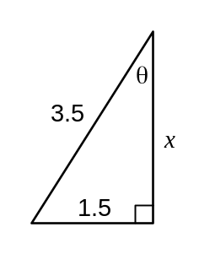

(ii) Calculate how far up the wall the ladder will reach, correct to one decimal place.
(3 marks)
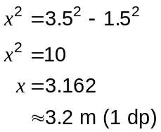

(iii) Calculate the angle between the ladder and the wall at the top of the ladder, correct to the nearest degree. (3 marks)
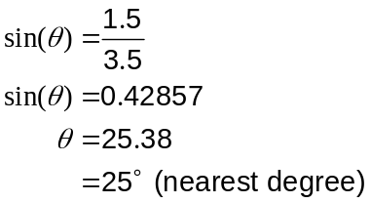

Question 9 (10 marks)
(a) A shop sells a brand of margarine in two different sizes: 550g for $4.95 and 200g for $1.75. Which size is the 'best buy'? Explain your answer. (3 marks)
Large: 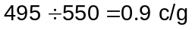

Small: 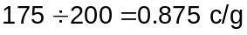

Hence SMALL size is slightly cheaper per gram than the large and so is the best buy.

(b) Three people bought a $4 500 painting as an investment. Of the $4 500, Aki and Beth contributed $2 400 and $900 respectively, with Ching putting in the rest.

(i) Write down the ratio of the contributions of Aki, Beth and Ching in simplest form.
(3 marks)
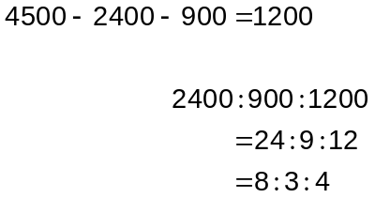

Two years later, the painting was sold for $7 500.

(ii) Calculate the percentage profit made by selling the painting. (2 marks)

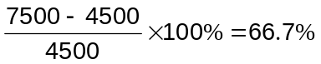

(iii) The three people shared the $7 500 sale proceeds in the ratio of their contributions. How much did Beth receive? (2 marks)
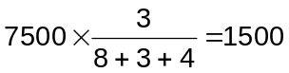

Question 10 (8 marks)
The table below shows the shortest time, in minutes, to travel along direct routes between the eight branches of a bank located within a city.

 | A | B | C | D | E | F | G | H
A | - | 8 | 7 | - | 7 | - | - | -
B | 8 | - | 3 | - | - | 7 | 11 | -
C | 7 | 3 | - | 5 | - | - | 13 | -
D | - | - | 5 | - | 6 | - | 8 | 11
E | 7 | - | - | 6 | - | - | - | 17
F | - | 7 | - | - | - | - | 3 | 8
G | - | 11 | 13 | 8 | - | 3 | - | 4
H | - | - | - | 11 | 17 | 8 | 4 | -

(a) Complete the network below (not drawn to scale) to show all the direct routes listed in the table. (3 marks)

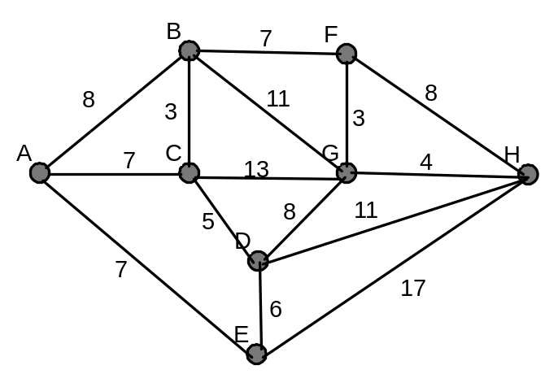

(b) Find the shortest time to travel from branch A to branch H through the network above and list in order the branches visited along this path. (3 marks)
Route: A - B - F - G - H.
Shortest time is 22 minutes.

(c) If improvements to the roads between branches E and H decreased the shortest time between them from 17 to 14 minutes, would this affect your answer to part (b)? Explain your answer. (2 marks)
Yes. Route now A - E - H and shortest time decreases to 21 minutes.

Question 11 (7 marks)
The ages of all 84 teachers in a school are summarised in the table below.
Age | Frequency
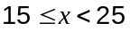 | 5
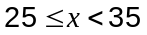 | 19
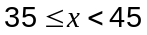 | 24
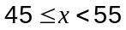 | 28
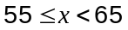 | 8

(a) Find the mean age of these teachers, correct to one decimal place. (2 marks)
Mean is 41.8 to 1 dp.

(b) Which group contains the median age? (1 mark)

(c) Is there a modal class? Briefly explain your answer. (1 mark)
Yes - the class has a higher frequency than the other classes.

(d) What fraction of the teachers were older than 44? (1 mark)
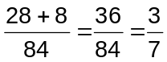

(e) At the end of term, a 62 year old teacher retired and was replaced by a 23 year old graduate teacher. Calculate the change in the mean age of the teachers, correct to one decimal place. (2 marks)
Change frequencies so that 8 -> 7 and 5 -> 6.
New mean = 41.3
Change is 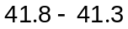, a decrease of 0.5 years.
Question 12 (8 marks)
(a) The line 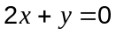 has been graphed on the axes below.
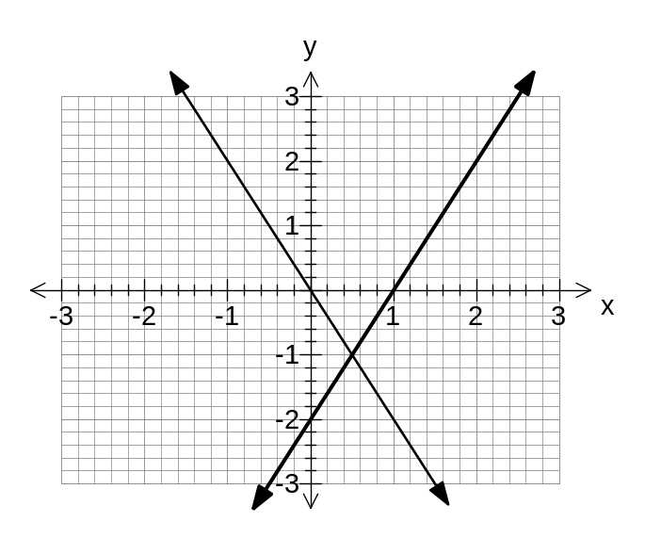

(i) Add the line 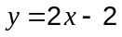 to the axes above. (2 marks)

(ii) Use the graph to solve the simultaneous equations and .
(2 marks)
Intersect when 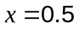 and 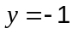

(b) Let two numbers be and , where is larger than .

(i) When twice the larger is added to the smaller number, the result is 40.
Write down this information as an equation. (1 mark)
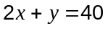

(ii) The larger number is one less than three times the smaller number.
Write down this information as another equation. (1 mark)
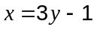

(iii) Solve your two equations simultaneously to find the values of and . (2 marks)
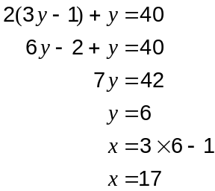

Question 13 (6 marks)
The brick paver shown in Figure 1 is used to create the paving design in Figure 2.
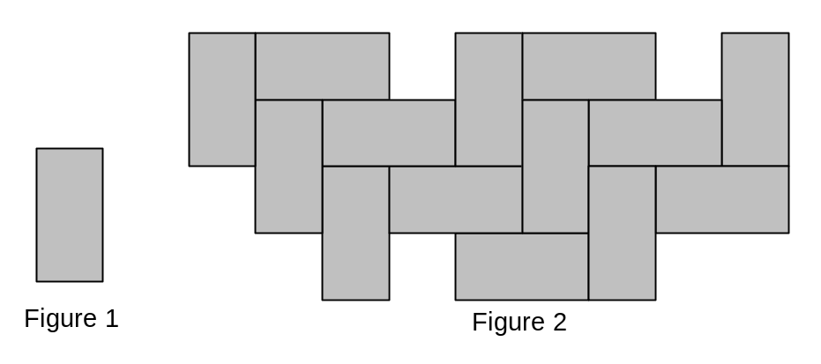

(a) State the two types of transformations used to move copies of the paver in Figure 1 to create the pattern in Figure 2. (2 marks)
- Translations

- Rotations

(b) How many lines of symmetry does the paver in Figure 1 have? (1 mark)
2

(c) What order of rotational symmetry does the paver in Figure 1 have? (1 mark)
2

(d) On the grid below use four pavers to create a pattern which has four lines of symmetry and at the same time has rotational symmetry of order four. (2 marks)
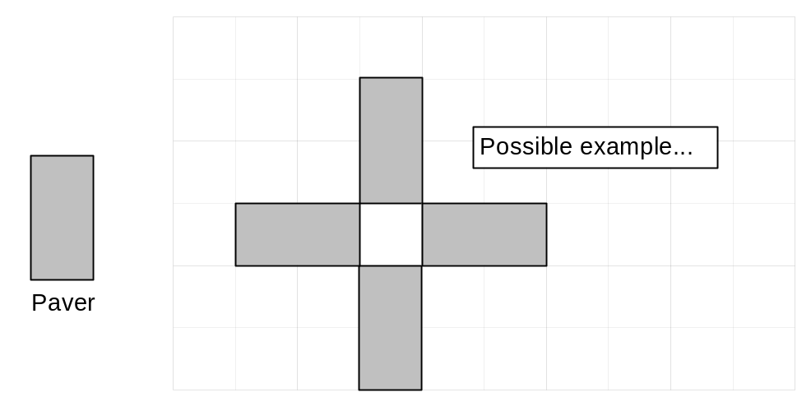

Question 14 (7 marks)
During the first five hours of an experiment, the area of a bacterial infection, ( in cm²), increased at an exponential rate given by 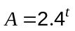, where is the number of hours since the experiment began.

(a) Use your calculator to complete the table below. (2 marks)

(hours) | 0 | 1 | 2 | 3 | 4 | 5
(cm²) | 1 | 2.4 | 5.8 | 13.8 | 33.2 | 79.6

(b) On the axes below draw the graph of . (3 marks)
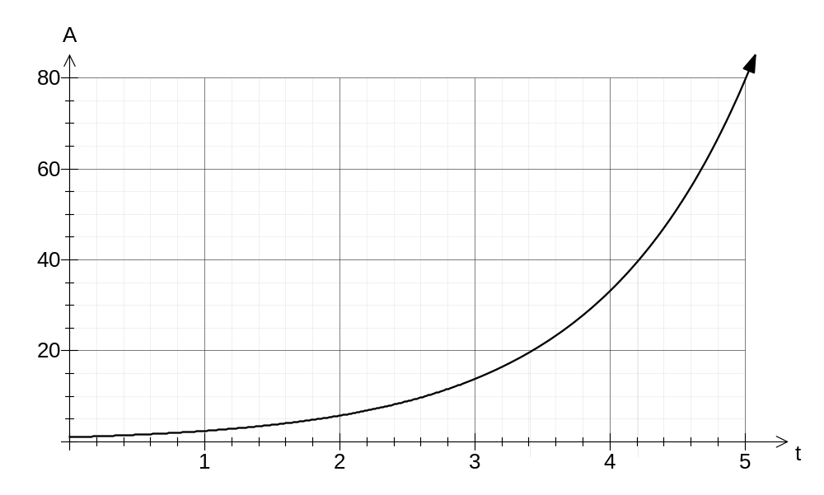

(c) Using your graph, or otherwise, how long did the area of the infection take to increase from 20 cm² to 40 cm²? (2 marks)

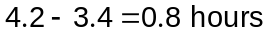

Question 15 (10 marks)
Marie is a proof-reader who charges her clients $80 per hour, plus a one-off fee of $40 per job.

(a) Calculate the two missing values in the table below to show the cost of various proof-reading jobs completed by Marie. (2 marks)

Time of job ( hours) | 2 | 3 | 6.5 | 8
Cost ( $) | 200 | 280 | 560 | 680

(b) Write a rule to calculate the cost , in dollars, of a proof-reading job that takes Marie hours to complete. (1 mark)
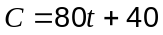

On the axes below, the cost of another person, Nadim, completing a proof-reading job which takes hours has been plotted.

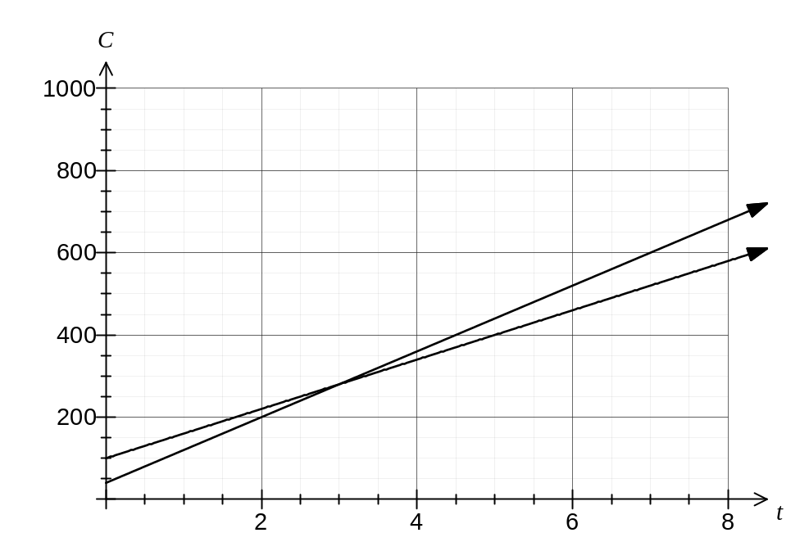

(c) Write a rule to calculate the cost , in dollars, of a proof-reading job that takes Nadim hours to complete. (2 marks)
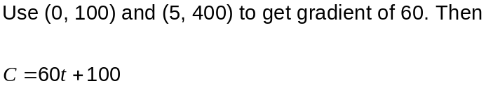

(d) Add to the axes on the previous page the graph of the cost of Marie completing a job which takes hours. (2 marks)
See graph

(e) For what length of job, to the nearest hour, would Marie and Nadim charge the same?
(1 mark)
3 hours

(f) If a company wanted to pay as little as possible for their proof-reading jobs, explain which proof-reader they should use. (2 marks)

For jobs of less than 3 hours, use Marie and for jobs longer than 3 hours, use Nadim.
For jobs of exactly 3 hours, choose either.

Question 16 (7 marks)
(a) Write down the next term in each of these number sequences:

(i) 63, 55, 47, 39, … (1 mark)
31

(ii) 2, 6, 18, 54, … (1 mark)
162

(iii) 10, 21, 43, 87, … (1 mark)
175

(b) The population of a city of 24 000 people is increasing by 2% per year. The future population of the city after years can be calculated using the recursive rule 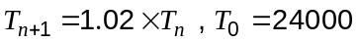.

Calculate the expected population of the city after 3 years. (2 marks)
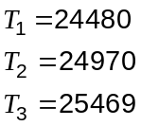

(c) A sequence is described by the recursive rule 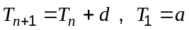.

If 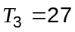 and 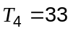, find the values of and . (2 marks)
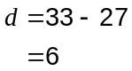
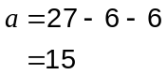

Question 17 (8 marks)
In a class of 29 students there were 13 boys, of whom 11 passed an English test. Only 3 students in the class failed the English test.

(a) Use this information to complete the two-way frequency table below: (2 marks)

 | Passed English Test | Failed English Test | Total
Boy | 11 | 2 | 13
Girl | 15 | 1 | 16
Total | 26 | 3 | 29

(b) How many girls passed the English test? (1 mark)

15 girls

(c) Calculate the percentage of the students that were girls who passed the test. (1 mark)
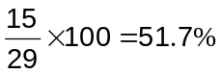

(d) If one student is chosen at random from this class, what is the probability that they will be a girl who failed the test? (1 mark)
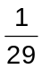

(e) If one of the boys is chosen at random from this class, what is the probability that they did not fail the test? (1 mark)
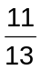

(f) The relative frequency of students passing the test in this class was the same as that of the whole year group of 145 students. How many students in the year group failed the test? (2 marks)
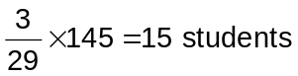

Question 18 (8 marks)
A number pattern is shown below.

Row | Calculation |  | Result
1 | 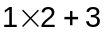 | = | 5
2 | 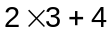 | = | 10
3 | 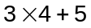 | = | 17
4 | 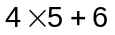 | = | 26
5 | 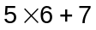 | = | 37
6 | 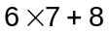 | = | 50

(a) Complete the next two rows of the pattern in the space above. (2 marks)

(b) Write down the calculation and result for row 36. (2 marks)

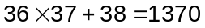

Consider the following conjecture concerning the above number pattern:

"If the row number is 1 more than a multiple of 5, then the result will also be a multiple of 5".

(c) Write down another three rows of the pattern to test this conjecture. (2 marks)

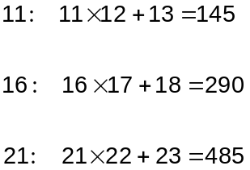

(d) Do you think the conjecture is true or false? Explain your answer. (2 marks)
On the basis of the above 3 rows, the conjecture appears to be true, although there may be cases yet to be tested where it is not.

Question 19 (7 marks)
(a) Lily and Said planned to collect data on the number of hours that the 30 students in their Year 11 class spent watching TV on a weekday night.

Time (hours) | Tally
0 - 1
1 - 2
2 or more
(i) Lily created a table as shown at right and planned to ask each student which group they belonged to.

Describe two advantages or disadvantages of her method. (2 marks)
D: Not clear into which group a response of 1 hour, etc, would go.
D: Not enough groups to get meaningful data to graph.
A: is quick and easy to carry out.
Etc

(ii) Said decided to ask each student and simply make a list of all their times.

Describe one advantage or disadvantage of his method. (1 mark)
D: More time consuming for follow up work.
A: Can group data later and still keep raw data.
Etc

(b) A fair six-sided dice with faces numbered from 1 to 6 is thrown 60 times and the score recorded each time.

(i) Sketch the shape of the frequency histogram that you would expect on the axes below. (2 marks)
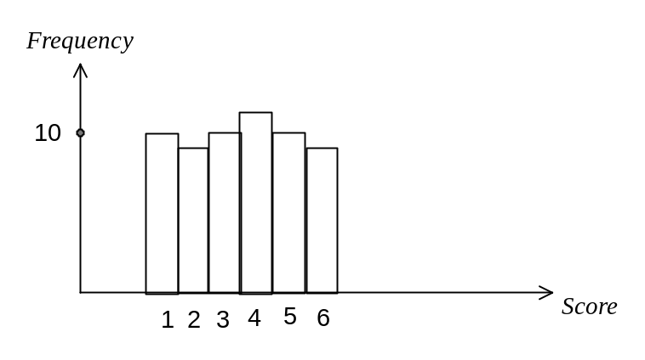

(ii) Explain the shape of your sketch graph. (1 mark)
Expect roughly similar numbers of each score, though not exactly the same.

(iii) If the dice was thrown another 60 times, how likely is it that the same numbers of each score would be recorded again? (1 mark)
Very unlikely
Question 20 (7 marks)
Consider the solid prism of length 30 cm shown in figure 1. The prism has a square cross-section with a quarter of a circle removed from the top right corner, as shown in figure 2. The square has a side length of 8 cm and the radius of the circle is 4 cm.
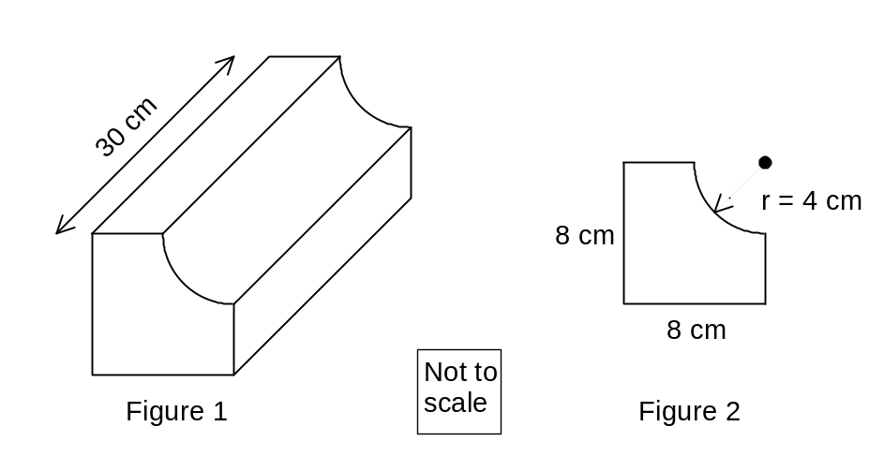

(a) Show that the area of the cross-section shown in Figure 2 is 51.43 cm², rounded to two decimal places. (2 marks)
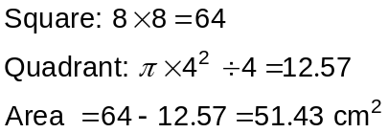

(b) Calculate the volume of the solid prism shown in Figure 1. (1 mark)

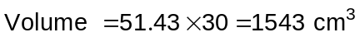

(c) Calculate the total surface area of the prism shown in Figure 1. (4 marks)
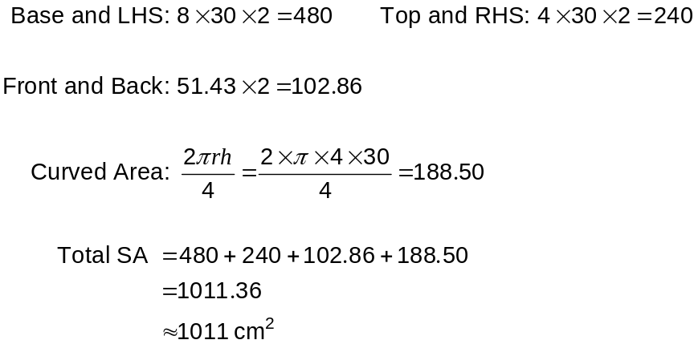

Additional working space

Question number: _________

Additional working space

Question number: _________

Additional working space

Question number: _________

This examination paper may be freely copied, or communicated on an intranet, for non-commercial purposes within educational institutes that have purchased the paper from WA Examination Papers provided that WA Examination Papers is acknowledged as the copyright owner. Teachers within purchasing schools may change the paper provided that WA Examination Paper's moral rights are not infringed.

Copying or communication for any other purposes can only be done within the terms of the Copyright Act or with prior written permission of WA Examination papers.

Published by WA Examination Papers
PO Box 445 Claremont WA 6910

